**Group 15**

**Group Details**

PE14- Payal Patil

PE16- Vaishanvi Salunke

PE29- Vasu Kalariya

PE30- Sakshi Patil

**Name of Topic**

SOCIAL DISTANCE DETECTOR

**Guided by:**

Dr. Pradnya Kulkarni

**Problem Statement:**

# To develop an efficient and highly trained Social distance detector system.

# Introduction

# Social distancing has been proven as an effective measure against the spread of the infectious COronaVIrus Disease 2019 (COVID-19). However, individuals are not used to tracking the required 6-feet (2-meters) distance between themselves and their surroundings. An active surveillance system capable of detecting distances between individuals and warning them can slow down the spread of the deadly disease. Furthermore, measuring social density in a region of interest (ROI) and modulating inflow can decrease social distancing violation occurrence chance. On the other hand, recording data and labeling individuals who do not follow the measures will breach individuals’ rights in free-societies. Here we propose an Artificial Intelligence (AI) based real-time social distancing detection and warning system considering four important ethical factors: (1) the system should never record/cache data, (2) the warnings should not target the individuals, (3) no human supervisor should be in the detection/warning loop, and (4) the code should be open-source and accessible to the public. Against this backdrop, we propose using a monocular camera and deep learning-based real-time object detectors to measure social distancing. If a violation is detected, a non-intrusive audio-visual warning signal is emitted without targeting the individual who breached the social distancing measure. Also, if the social density is over a critical value, the system sends a control signal to modulate inflow into the ROI. We tested the proposed method across realworld datasets to measure its generality and performance. The proposed method is ready for deployment, and our code is open-sourced 1 .

# YOLO algorithm

# YOLO is an algorithm that uses neural networks to provide real-time object detection. This algorithm is popular because of its speed and accuracy. It has been used in various applications to detect traffic signals, people, parking meters, and animals.

# YOLO algorithm employs convolutional neural networks (CNN) to detect objects in real-time. As the name suggests, the algorithm requires only a single forward propagation through a neural network to detect objects.

This means that prediction in the entire image is done in a single algorithm run. The CNN is used to predict various class probabilities and bounding boxes simultaneously.

The YOLO algorithm consists of various variants. Some of the common ones include tiny YOLO and YOLOv3.

**Result**

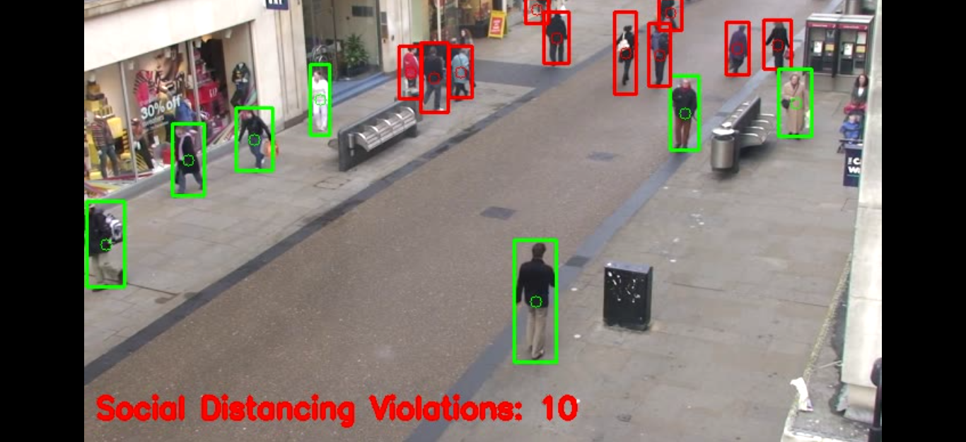

**References**

1. **https://www.researchgate.net/profile/EkimYurtsever/pblication/342763051_A_Visionbased_Social_Distancingand_Critical_Density_Detection_System_for_COVID19/links/5f08fbdc92851c52d628c8eb/A-Vision-based-Social-Distancing-and-Critical-Density-Detection-System-for-COVID-19.pdf**